TUTORIAL – 6: REQUIREMENT REVIEW / WALKTHROUGH / INSPECTION
Website: DemoBlaze
Aim:
To review the Product and Cart requirements of DemoBlaze, identify whether each requirement is clear and testable, and prepare simple test cases for the main product and cart activities.
Description
Requirement review is done before testing so that unclear requirements can be identified early. A clear requirement should be easy to understand and should give enough information to create a test case.
Problem Statement
Review the Product and Cart requirements of DemoBlaze and prepare test cases for viewing products, selecting a product, viewing details, adding to cart, opening the cart, checking the product in the cart and removing the product.
Parameter Details
Project Name | DemoBlaze
Application / Software | Web Application
Website | DemoBlaze
Module Name | Product and Cart Module
Testing Type | Functional Testing
Testing Approach | Black Box Testing
Browser | Google Chrome
Requirement Review
Requirement | Test Case | Clear / Unclear | Reason | Status
User should be able to view available products. | TC01 | Clear | The requirement is directly visible and testable. | PASS
User should be able to select a product. | TC02 | Clear | A product can be selected and opened. | PASS
User should be able to view product details. | TC03 | Clear | Product details can be checked from the product page. | PASS
User should be able to add a product to the cart. | TC04 | Clear | The Add to cart action is directly testable. | PASS
User should be able to open the cart. | TC05 | Clear | Cart navigation can be checked easily. | PASS
Added product should be visible in the cart. | TC06 | Clear | The product presence can be verified in the cart. | PASS
Customer should be able to enter required details. | TC07 | Clear | Required fields are mentioned and can be tested. | PASS
Customer should be able to submit the order. | TC08 | Clear | The Purchase action and expected confirmation are testable. | PASS
Test Cases Detailed
TC01 –Products
Test Case ID | TC01
Module Name | Product and Cart
Feature Under Test | View Products
Test Objective | Check that products are displayed correctly on the website.
Test Type | Functional Testing
Test Technique | Black Box Testing
Priority | Medium
Preconditions | Open DemoBlaze home page.
Test Environment | Web Browser / Google Chrome
Test Data | DemoBlaze home page
Expected Result | Products should be visible with product names/images.
Actual Result | Products are displayed on the home page.
Status | PASS
Executed By | Shivam
Execution Date
Test Case Execution
Step No. | Test Steps | Input | Expected Result | Actual Result | Status
1 | Open website | - | Products should be visible with product names/images. | Products are displayed on the home page. | PASS
2 | Check the Products section | DemoBlaze home page | Products should be visible with product names/images. | Products are displayed on the home page. | PASS
Screenshot:
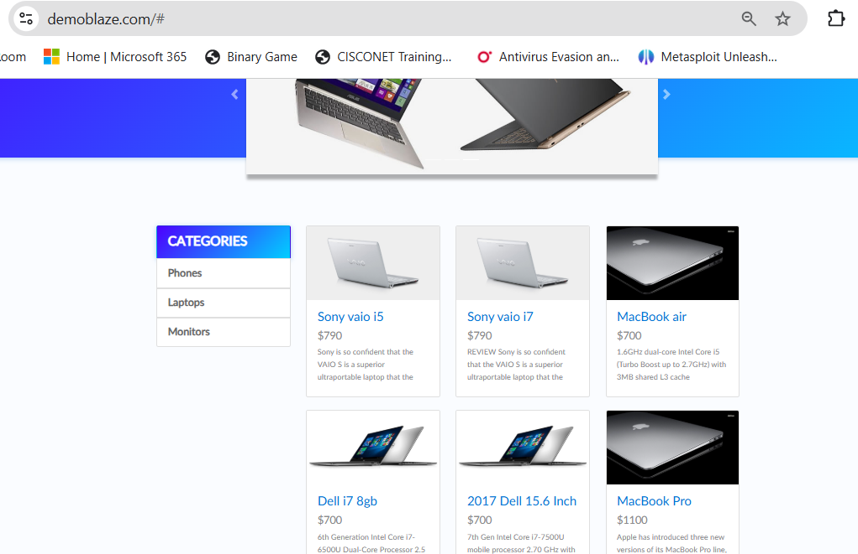

TC02 – Select Product
Test Case ID | TC02
Module Name | Product and Cart
Feature Under Test | Select Product
Test Objective | Check that a user can select a product from the product list.
Test Type | Functional Testing
Test Technique | Black Box Testing
Priority | Medium
Preconditions | Product list is visible.
Test Environment | Web Browser / Google Chrome
Test Data | Any available product
Expected Result | Selected product should open.
Actual Result | The selected product opens successfully.
Status | PASS
Executed By | Shivam
Execution Date
Test Case Execution
Step No. | Test Steps | Input | Expected Result | Actual Result | Status
1 | Open website | - | Selected product should open. | The selected product opens successfully. | PASS
2 | Click a product | Any available product | Selected product should open. | The selected product opens successfully. | PASS
Screenshot:
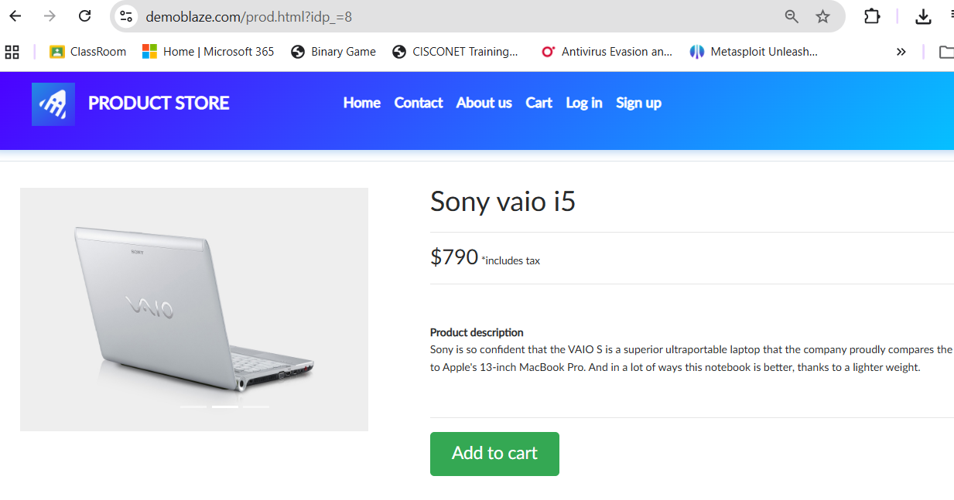

TC03 –Product Details
Test Case ID | TC03
Module Name | Product and Cart
Feature Under Test | View Product Details
Test Objective | Check that product details are shown correctly.
Test Type | Functional Testing
Test Technique | Black Box Testing
Priority | Medium
Preconditions | A product has been selected.
Test Environment | Web Browser / Google Chrome
Test Data | Selected product
Expected Result | Product name, price and details should be displayed.
Actual Result | Product details are displayed for the selected product.
Status | PASS
Executed By | Shivam
Execution Date
Test Case Execution
Step No. | Test Steps | Input | Expected Result | Actual Result | Status
1 | Open a product | - | Product name, price and details should be displayed. | Product details are displayed for the selected product. | PASS
2 | View product details | Selected product | Product name, price and details should be displayed. | Product details are displayed for the selected product. | PASS
Screenshot:
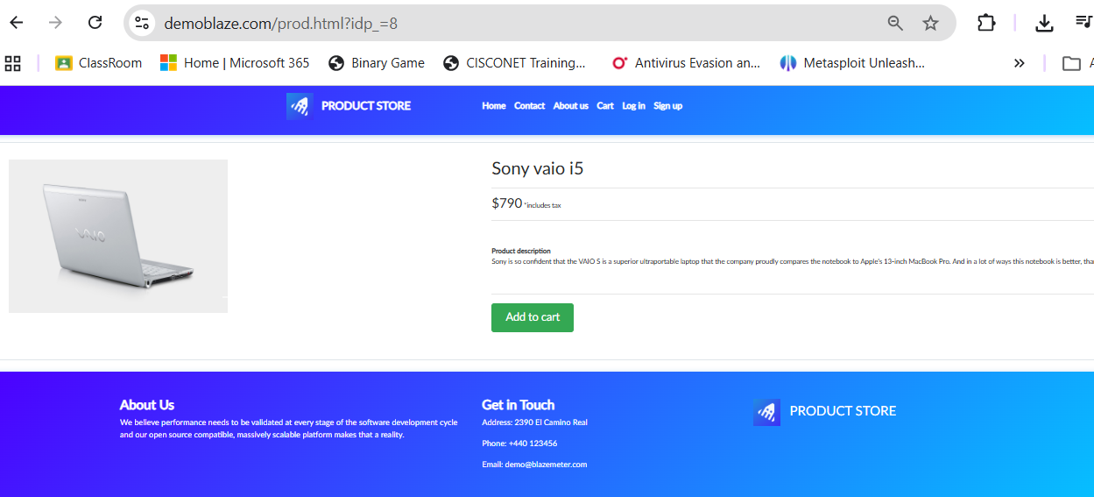

TC04 – Add Product
Test Case ID | TC04
Module Name | Product and Cart
Feature Under Test | Add Product
Test Objective | Check that a product can be added to the cart.
Test Type | Functional Testing
Test Technique | Black Box Testing
Priority | Medium
Preconditions | Product details page is open.
Test Environment | Web Browser / Google Chrome
Test Data | Any available product
Expected Result | Product should be added to the cart.
Actual Result | Product is added to the cart successfully.
Status | PASS
Executed By | Shivam
Execution Date
Test Case Execution
Step No. | Test Steps | Input | Expected Result | Actual Result | Status
1 | Open product | - | Product should be added to the cart. | Product is added to the cart successfully. | PASS
2 | Click Add to cart | Any available product | Product should be added to the cart. | Product is added to the cart successfully. | PASS
3 | Confirm the action | - | Product should be added to the cart. | Product is added to the cart successfully. | PASS
Screenshot:
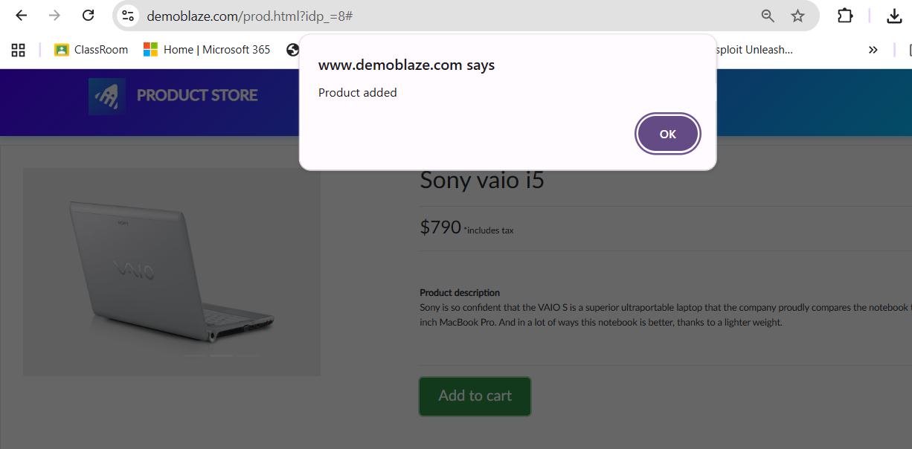

TC05 –Cart
Test Case ID | TC05
Module Name | Product and Cart
Feature Under Test | Open Cart
Test Objective | Check that the cart page opens correctly.
Test Type | Functional Testing
Test Technique | Black Box Testing
Priority | Medium
Preconditions | At least one product has been added.
Test Environment | Web Browser / Google Chrome
Test Data | Cart
Expected Result | Cart page should open and show the cart contents.
Actual Result | Cart page opens successfully.
Status | PASS
Executed By | Shivam
Execution Date
Test Case Execution
Step No. | Test Steps | Input | Expected Result | Actual Result | Status
1 | Click Cart | - | Cart page should open and show the cart contents. | Cart page opens successfully. | PASS
Screenshot:
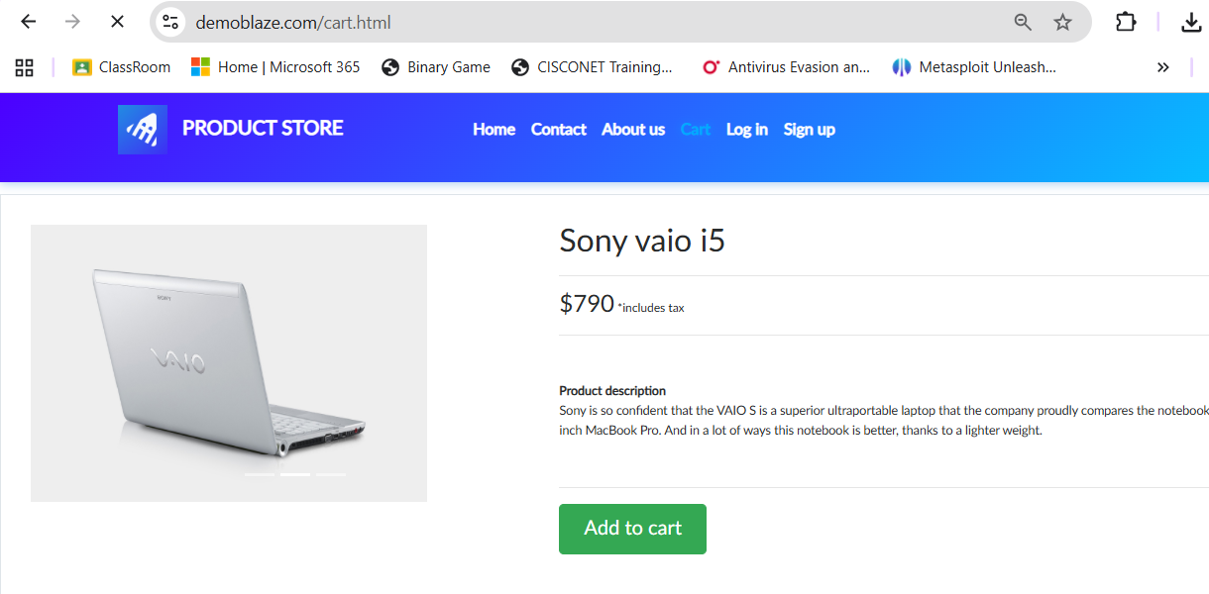

TC06 – Verify Product in Cart
Test Case ID | TC06
Module Name | Product and Cart
Feature Under Test | Verify Product in Cart
Test Objective | Check that the added product appears in the cart.
Test Type | Functional Testing
Test Technique | Black Box Testing
Priority | Medium
Preconditions | A product has already been added.
Test Environment | Web Browser / Google Chrome
Test Data | Added product
Expected Result | The selected product should be visible in the cart.
Actual Result | Added product is visible in the cart.
Status | PASS
Executed By | Shivam
Execution Date
Test Case Execution
Step No. | Test Steps | Input | Expected Result | Actual Result | Status
1 | Open Cart | - | The selected product should be visible in the cart. | Added product is visible in the cart. | PASS
2 | Check the product row | Added product | The selected product should be visible in the cart. | Added product is visible in the cart. | PASS
Screenshot:
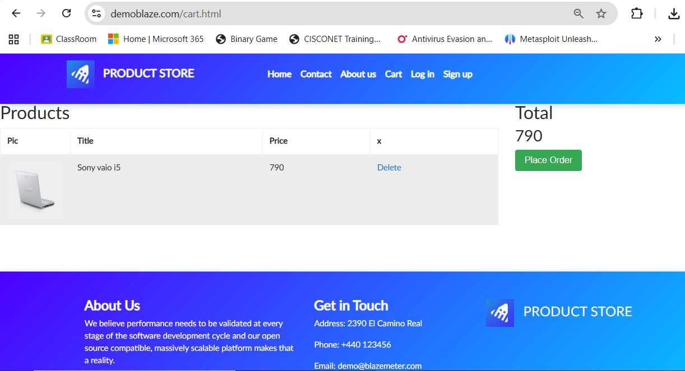

TC07 – Customer Details
Test Case ID | TC07
Module Name | Order Module
Feature Under Test | Customer Details
Test Objective | Check whether customer details can be entered.
Test Type | Functional Testing
Test Technique | Black Box Testing
Priority | High
Preconditions | Place Order form is open.
Test Environment | Web Browser / Google Chrome
Test Data | Name, Country, City, Credit Card, Month, Year
Expected Result | Details should be accepted successfully.
Actual Result | Details were accepted successfully.
Status | PASS
Executed By | Shivam
Execution Date
Screenshot:
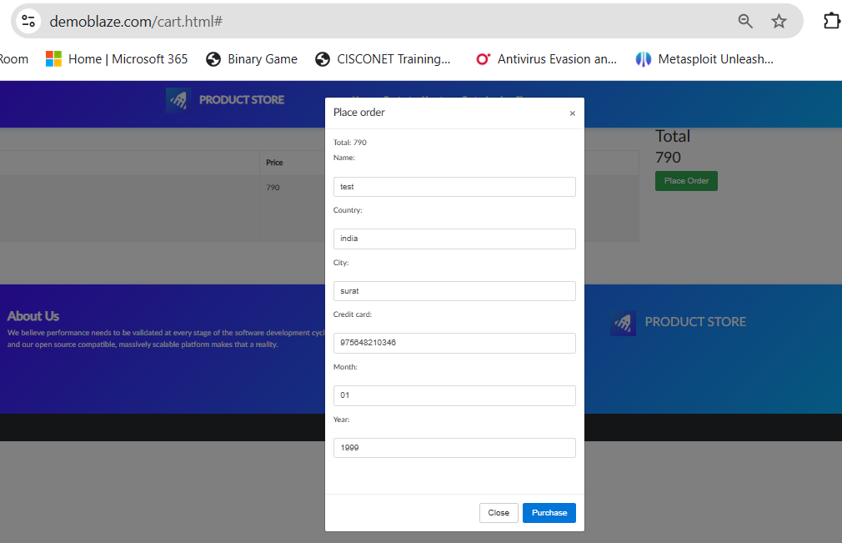

TC08 –Submit Order
Test Case ID | TC08
Module Name | Order Module
Feature Under Test | Submit
Test Objective | Check whether order details can be submitted.
Test Type | Functional Testing
Test Technique | Black Box Testing
Priority | High
Preconditions | Customer details are entered.
Test Environment | Web Browser / Google Chrome
Test Data | Valid customer details
Expected Result | Order should be submitted with confirmation.
Actual Result | Order was submitted and confirmation was displayed.
Status | PASS
Executed By | Shivam
Execution Date

Screenshot:
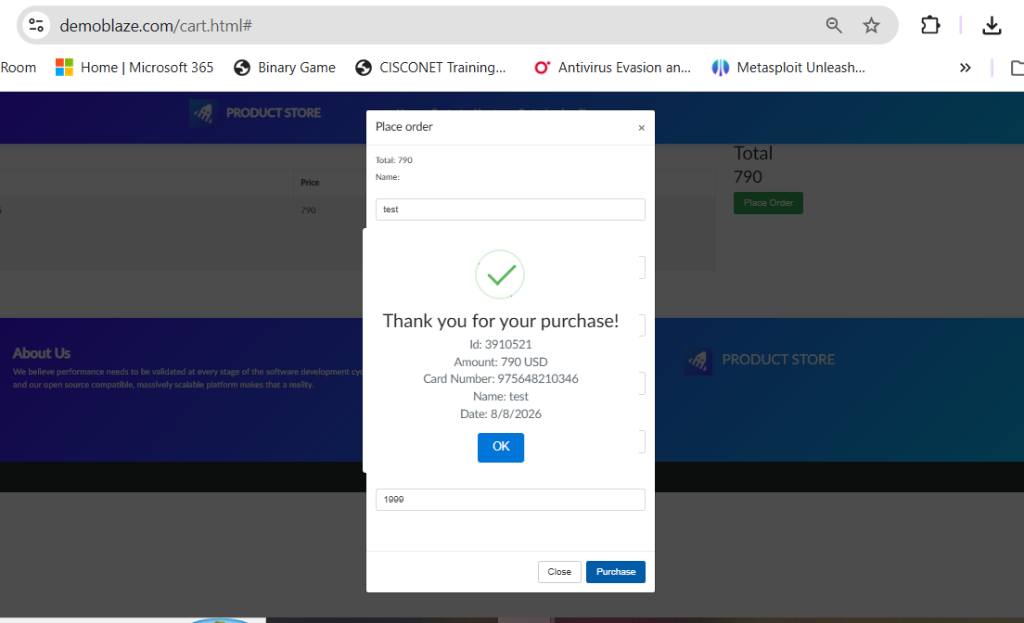

Testing Activities Performed
Sr. No. | STLC Phase | Testing Activity | Deliverable / Artifact | Status
1 | Requirement Review | Review Product/Cart requirements | Requirement Review Table | Completed
2 | Test Planning | Define testing scope | Test Plan | Completed
3 | Test Case Design | Prepare 7 test cases | Test Case Document | Completed
4 | Test Execution | Execute product/cart scenarios | Execution Report | Completed
5 | Test Closure | Prepare final summary | Execution Summary | Completed
Observation
Sr. No. | Observation | Remarks
1 | Check that products are displayed correctly on the website. | PASS
2 | Check that a user can select a product from the product list. | PASS
3 | Check that product details are shown correctly. | PASS
4 | Check that a product can be added to the cart. | PASS
5 | Check that the cart page opens correctly. | PASS
6 | Check that the added product appears in the cart. | PASS
7 | Required fields are mentioned and can be tested. | PASS
8 | The Purchase action and expected confirmation are testable. | PASS
Test Execution Summary
Total Test Cases | 8
Passed | 8
Failed | 0
Blocked | 0
Pass % | 100%
Overall Result | PASS
Conclusion
The Product and Cart requirements of DemoBlaze were reviewed and converted into seven simple test cases. The main functional requirements are clear and testable. The statement 'Website should be fast' is marked unclear because no response-time value is specified, as shown in the Tutorial 3 requirement-review example.

